**1.1**

**Android Introduction**

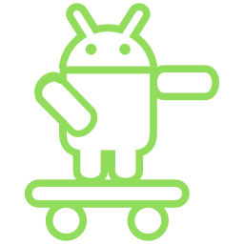

**What is Android?**

**Android** is an open source operating system based on Linux with a Java programming interface for mobile devices such as Smartphone (Touch Screen Devices who supports Android OS) as well for Tablets too.

Android was developed by the **Open Handset Alliance** (OHA), which is led by Google. The **Open Handset Alliance** (OHA) is consortium of multiple companies like Samsung, Sony, Intel and many more to provide a services and deploy handsets using android **platform.**

**OHA (Open Handset Alliance)**

The Open Handset Alliance (OHA) is a business alliance that was created for the purpose of developing open mobile device standards. The OHA has approximately 86 (2017)/84 (2020) member companies, including HTC, Dell, Intel, Motorola, Qualcomm and Google. The OHA's main product is the Android platform - the world's most popular smartphone platform.

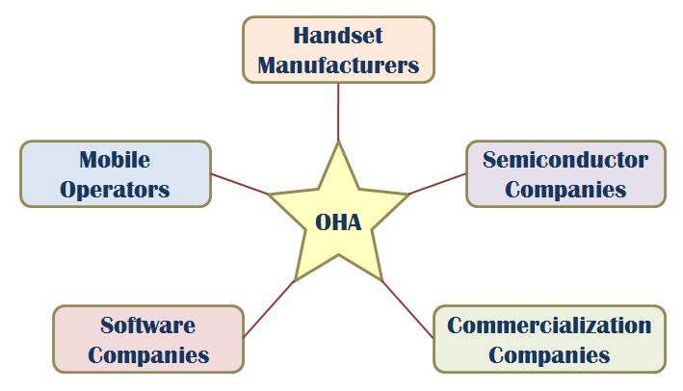

**What is Platforms?**

Any hardware or software environment in which a program runs, is known as a platform. Since Android has its own runtime environment (JRE) and API, it is called platform.

**Other Platforms:**

iOS, Symbian, Windows Phone-7, Blackberry OS etc.

**Good Platforms**

* Android – Open source mobile OS developed by the Open Handset Alliance led by Google. Based on Linux 2.6 kernel
* iOS – Apple’s proprietary mobile OS, iPhone, iPod Touch, iPad. Derived from OS X, very UNIX like
* Symbian – acquired by Nokia 2008
* Windows Phone 7 – Microsoft – Kin, discontinued 6 weeks after initial launch
* Blackberry OS – RIM (Research in Motion), proprietary OS

### **The Smartphone Platform**

### With the iPhone being the first to the marketplace it sets the configuration of the Smartphone Platform

### 3G/4G/5G… connectivity

### WiFi connectivity

### Bluetooth connectivity

### Accelerometer w/compass

### Ambient light sensor

### Proximity sensor

### GPS

### Gyroscope

**Android Features**

Android is a powerful open source operating system which provides a lot of great features, those are

* It’s an open source and we can customize the OS based on our requirements.
* It support a connectivity for GSM, CDMA, WIFI, NFC, Bluetooth, etc. for telephony or data transfer. It will allow us to make or receive a calls / SMS messages and we can send or retrieve a data across mobile networks
* By using WIFI technology we can pair with other devices using apps
* Android have a multiple APIs to support a location-based services such as GPS
* We can perform all data storage related activities by using light weight database [SQLite](https://www.tutlane.com/tutorial/sqlite).
* It have a wide range of media supports like AVI, MKV, FLV, MPEG4 etc. to play or record variety of audio / video and having a different image formats like JPEG, PNG, GIF, BMP, MP3, etc.
* It has an extensive support for multimedia hardware control to perform playback or recording using camera and microphone
* It has an integrated open source Webkit layout based web browser to support HTML5, CSS3
* It supports a multi-tasking, we can move from one task window to another and multiple applications can run simultaneously
* It will give a chance to reuse the application components and the replacement of native applications.
* We can access the hardware components like Camera, GPS, and Accelerometer
* It has a support for 2D/3D/4G Graphics

## Table: Android Features

|  |  |
| --- | --- |
| **Sr. No.** | **Feature & Description** |
| 1 | **Beautiful UI**  Android OS basic screen provides a beautiful and intuitive user interface. |
| 2 | **Connectivity**  GSM/EDGE, IDEN, CDMA, EV-DO, UMTS, Bluetooth, Wi-Fi, LTE, NFC and WiMAX. |
| 3 | **Storage**  SQLite, a lightweight relational database, is used for data storage purposes. |
| 4 | **Media support**  H.263, H.264, MPEG-4 SP, AMR, AMR-WB, AAC, HE-AAC, AAC 5.1, MP3, MIDI,  Ogg Vorbis, WAV, JPEG, PNG, GIF, and BMP. |
| 5 | **Messaging**  SMS and MMS |
| 6 | **Web browser**  Based on the open-source WebKit layout engine, coupled with Chrome's V8 JavaScript engine supporting HTML5 and CSS3. |
| 7 | **Multi-touch**  Android has native support for multi-touch which was initially made available in handsets such as the HTC Hero. |
| 8 | **Multi-tasking**  User can jump from one task to another and same time various application can run simultaneously. |
| 9 | **Resizable widgets**  Widgets are resizable, so users can expand them to show more content or shrink them to save space. |
| 10 | **Multi-Language**  Supports single direction and bi-directional text. |
| 11 | **GCM**  Google Cloud Messaging (GCM) is a service that lets developers send short message data to their users on Android devices, without needing a proprietary sync solution. |
| 12 | **Wi-Fi Direct**  A technology that lets apps discover and pair directly, over a high-bandwidth peer-to-peer connection. |
| 13 | **Android Beam**  A popular NFC-based technology that lets users instantly share, just by touching two NFC-enabled phones together. |

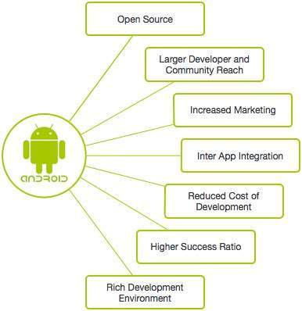

## Fig: Android Features

### **Android Versions and API Levels**

* API (Application Program Interface) Level is an integer value that uniquely identifies the framework API revision offered by a version of the Android platform.
* Each Android version is assigned a unique integer identifier, called the *API Level*. Therefore, each Android version corresponds to a single Android API Level. Because users install apps on older as well as the most recent versions of Android, real-world Android apps must be designed to work with multiple Android API levels.

Since the release, Android has gone through number of updates. Here is the list of its different versions and their code names:

**Android History**

Initially Google launched a first version of Android platform on Nov 5, 2007 from that onwards Google released a lot of android versions under a codename based on desserts, such as Apple Pie, Banana Bread, Cupcake, Donut, Éclair, Froyo, Gingerbread, Jellybeans, Kitkat, Lollipop, marshmallow, etc. and made a lot of changes and additions to the android platform.

In **2007**, Google released a first beta version of the Android Software Development Kit (SDK) and the first commercial version of Android **1.0** (with name **Alpha**), was released in September **2008**.

In **2012**, Google released another version of android, 4.1 **Jelly Bean**. It’s an incremental update and it improved a lot in terms of user interface, functionality and performance.

In **2014**, Google announced another Latest Version, 5.0 **Lollipop**. In Lollipop version Google completely revamped the UI by using Material Designs, which is good for the User Interface as well for the themes related.

All the source code for Android is available free on Git-Hub, Stack overflow and many more websites. Google publishes most of the code under the Apache License version 2.0.

Following table shows the version details of android which is released by Google from 2007 to till date.

For each version Google has made a lot of changes and introduced lot of new features due to that the usage of android in mobile market increased drastically.

**Table:** Android versions with API Level

|  |  |  |  |
| --- | --- | --- | --- |
| **Version** | **Release Date** | **Code Name** | **API Level** |
| 1.0 | 23 Sep, 2008 | Alpha/Apple Pie/NA | 1 |
| 1.1 | 9 Feb, 2009 | Banana Bread/NA | 2 |
| 1.5 | 30 Apr, 2009 | Cupcake | 3 |
| 1.6 | 15 Sep, 2009 | Donut | 4 |
| 2.0/2.1 | 26 Oct, 2009 | Éclair | 5-7 |
| 2.2 | 20 May, 2010 | Froyo | 8 |
| 2.3 | 6 Dec, 2010 | Gingerbread | 9-10 |
| 3.0/3.1/3.2 | 22 Feb, 2011 | Honeycomb | 11-13 |
| 4.0 | 18 Oct, 2011 | Ice Cream Sandwich | 14-15 |
| 4.1/4.2/4.3 | 9 Jul, 2012 | Jelly Bean | 16-18 |
| 4.4 | 31 Oct, 2013 | KitKat | 19-20 |
| 5.0/5.1 | 12 Nov, 2014 | Lollipop | 21-22 |
| 6.0 | 5 Oct, 2015 | Marshmallow | 23 |
| 7.0 | 2016 End | Nougat | 24 |
| 8.0 | 21 Aug, 2017 | Oreo | 26 |
| 9.0 | 6 Aug, 2018 | Pie | 28 |
| 10 | 23 Sept, 2019 | Android 10/ Quince tart |  |
| 11 |  | Android 11/Red Velvet Cake |  |
| 12 |  | Android 12/ Snow cone |  |
| 13 |  | Android 13/Tiramisu |  |

## Android 9.0 Popcorn (by Google)

Android 9.0 Pastry Android 9.0 Pasta

Android Pastilla Android 9.0 Puff

Android 9.0 Pandoro Android 9.0 Panna Cotta

Android 9.0 Parfait Android 9.0 Popover

Android 9.0 PanCake Android 9.0 Peanut Brittle

Android 9.0 Pumpkin Pie Android 9.0 Popsicle

Android 9.0 Pecan Pie Android 9.0 Poached Pears

Android 9.0 Praline Android 9.0 Pastille

Android 9.0 Petit Four Android 9.0 Pinka

Android Piano Android Pillow

Android Pilot Android Pudding

Android Pie

**Other suggested Android 9.0 version**

* Penuche
* Pignolo
* Pizzelle
* Pecan Pie
* Pavlova
* Profiterole
* Pop Tart

**Android P Indian Names**

* Android 9.0 Peda
* Android Pista
* Android Pilu

**Key additions of Different Versions**

|  |  |  |
| --- | --- | --- |
| **No** | **Code Name/Version** | **Key Additions/Features** |
| 1. | **No Codename** (v1.0) | Google Android 1.0 officially arrived September 23rd, 2008, as the only release of Android (so far) to not include a codename |
| 2. | **Petit Four** (v1.1) | "Petit Four" began rolling out in early 2009 as the first update for the new Google Android mobile operating system. |
| 3. | [Cupcake](https://www.webopedia.com/TERM/C/Cupcake.html) (v1.5) | Speech recognition tools, a virtual keyboard, video upload support for YouTube and support for live data feeds and live folders. |
| 4. | [Donut](https://www.webopedia.com/TERM/D/donut.html) (v1.6) | Support for CDMA smartphones, additional screen sizes and a text-to-speech engine. |
| 5. | [Eclair](https://www.webopedia.com/TERM/E/eclair.html) (v2.0) | Support for multi-touch devices, new browser interface, Microsoft Exchange support, single interface for managing multiple online accounts, soft keys support, and an enhanced camera app (with digital zoom and flash support). |
| 6. | [FroYo](https://www.webopedia.com/TERM/F/froyo.html) (v2.2) | USB [tethering](https://www.webopedia.com/TERM/T/tethering.html) support (for turning a smartphone into a [Wi-Fi](https://www.webopedia.com/TERM/W/Wi_Fi.html)hotspot), significant speed improvements, Flash 10.1 support, voice dialing over Bluetooth, the ability to store apps on external memory cards, updated browser with Google Chrome's V8 JavaScript. |
| 7. | [Gingerbread](https://www.webopedia.com/TERM/G/gingerbread.html) (v2.3) | Google Voice over Wi-Fi, enhanced gaming functionality, improved Google Apps. |
| 8. | [Honeycomb](https://www.webopedia.com/TERM/A/android_honeycomb.html) (v3.0) | A tablet-centric update that delivered a new interface optimized for devices with larger screen sizes (particularly [tablets](https://www.webopedia.com/TERM/T/tablet_PC.html)), video chat support based on Google Talk protocols, new System Bar for global status and notifications and Action Bar for application control, [tabbed Web browsing](https://www.webopedia.com/TERM/T/tabbed_browsing.html), optimized soft keyboard and a new email interface. |
| 9. | [Ice Cream Sandwich](https://www.webopedia.com/TERM/I/ice_cream_sandwich.html) (v4.0) | A smartphone-centric update based on the [Linux](https://www.webopedia.com/TERM/L/Linux.html) kernel v3.0.1 that brings many of Honeycomb's features to smartphones, including Face Unlock [facial recognition](https://www.webopedia.com/TERM/F/face_recognition.html) software, tabbed Web browsing capabilities, unified social networking contacts, 1080p video recording capabilities and video chat support based on Google Talk protocols. |
| 10. | [Jelly Bean](https://www.webopedia.com/TERM/J/jelly_bean.html) (v4.1, v4.2 and v4.3) | Advanced natural language voice command capabilities akin to Apple's [Siri](https://www.webopedia.com/TERM/S/siri.html), enhanced interface and overall responsiveness via "[Project Butter](https://www.webopedia.com/TERM/G/google_project_butter.html)," Google Now support, an improved Web browser, enhanced file management capabilities and more. |
| 11. | [KitKat](https://www.webopedia.com/TERM/K/kitkat.html) (v4.4) | Full-screen immersive mode, new transitions framework, and "Project Svelte," a project initiated to reduce the memory needs of the Android OS. Originally internally referred to as [Key Lime Pie](https://www.webopedia.com/TERM/K/key_lime_pie.html), Google announced in early September 2013 that it would be using the iconic candy bar as the codename for the 4.4 Android release. |
| 12. | [Lollipop](https://www.webopedia.com/TERM/L/lollipop.html) (v5.0) | Enhanced Material Design user interface, improved continuity across Android devices, multiple user support, a guest user account option, a new notification system, support for 64-bit CPUs, and more. |
| 13. | [Marshmallow](https://www.webopedia.com/TERM/M/marshmallow.html) (v6.0) | Now on Tap functionality and other Google Now enhancements, native fingerprint authentication support, Android Pay integration, USB Type-C support, improved battery life, better app management and more. |
| 14. | [Oreo](https://www.webopedia.com/TERM/O/oreo.html)  (v8.0) | Android Go minimized version of Android mobile OS, picture-in-picture video support, Notification Grouping, Bluetooth 5 support, Wi-Fi Aware feature, and more. |
| 15. | [Pie](https://www.webopedia.com/TERM/P/pie.html) (v9.0) | Adaptive Battery, Digital Well-being Dashboard (monitors screen time usage), App Slices, Intuitive Gestures, Adaptive Brightness, and more. |
| 16 | Android 10 | Dark mode, QR Code for WiFi, Audio features, Thermal API, Settings Panels, Bubbles, Location permissions, Privacy, Foldable devices, and more. |
|  | Android 11 |  |

# Android Applications

* Android applications are usually developed in the Java language using the Android Software Development Kit.
* Once developed, Android applications can be packaged easily and sold out either through a store such as
* Google Play,
* SlideME,
* Opera Mobile Store,
* Mobango,
* F-droid and
* Amazon Appstore

**Google Play:** Formerly known as the Android Market, is the official app store for Android smartphones and tablets. Google makes software applications, music, movies and books available for purchase and download through the store.

**SlideME:** A Community & Content Marketplace, uniting developers and users, offers products, services and experience that help promote small Android developers and their creative efforts, without locking them into any closed standards.

**Opera Mobile Store:** Offers a large number of applications for Android besides other *mobile* platforms.

**MOBANGO:** A mobile community enabling mobile users to publish, convert and share user generated content with others.

***F*-*Droid*:** A software repository (or "app store") for Android applications, similar to the Google Play store.

**Amazon Appstore:** An app store for the Android operating system operated by Amazon.com.

## Android Devices in Market

A device that runs Android OS comes in all shapes and sizes. Various devices that run Android OS and Apps are as follows:

* Smartphones
* Smart-watches
* Tablets
* E-reader Devices
* Netbooks
* MP4 Players
* Internet TVs and more.

Every day more than 1 million new Android devices are activated worldwide (more than 190 countries around the world).

**Android Mobile Company**

A large no of mobile companies are using Android. A list of companies supporting Android in their hardware are:

* + - Acer Inc
    - ALCATEL ( TCL corporation )
    - Bluelans Communications
    - NCE casio Mobile Communications
    - Cherry Mobile
    - CSL
    - Dell
    - Garmin
    - Geeks Phone
    - General Mobile
    - High screen
    - HKC
    - HTC coroporation
    - Huawei
    - I-mobile
    - Lenovo
    - LG
    - Motorola
    - Samsung
    - Sony Ericsson
    - Videocon
    - ZTE

## Other Mobile OSs

There are different other Mobile operating systems also present in market in competition with Android. Apple's iOS and Windows Phone give strong competition to Android. A simple comparison between features and specifications of latest version of Android and other Operating Systems can be seen in the table given below.

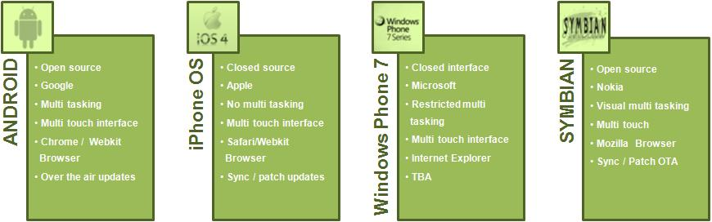

**Fig.** Various Mobile Operating System Available In Markets

According to Canalys, In Q2 2009 Android had 2.8% market share which had grown to 33% market share by Q4 2010 which made Android leader of smart phone OSs worldwide. The market share for commonly used mobile OSs is shown in the following pie chart.

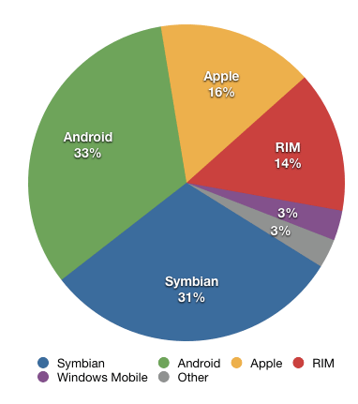

# Fig. Diagram Showing Market Share for Commonly Used Mobile OSs

**About the Brick:**

* The Motorola DynaTAC 8000X was the first commercially available cell phone.
* First marketed in 1983, it was 13 x 1.75 x 3.5 inches in dimension, weighed about 2.5 pounds, and allowed us to talk for a little more than half an hour.
* It retailed for $3,995, plus hefty monthly service fees and per-minute charges.
* It made calls, and there was a simple contacts application included in the operating system.

**Martin Cooper**

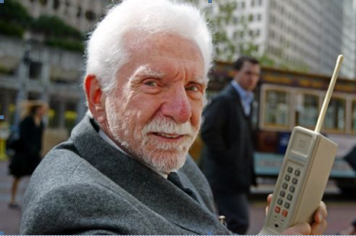

Martin Cooper holds a Motorola DynaTAC A 1973 prototype of the first handheld cellular telephone on Market Street in San Francisco in 2003.

## Questions

1. Define Android and Platforms.
2. What is Open Handset Alliance (OHA) and what is its purpose?
3. Mention some good platforms with example.
4. Mention some smartphone platforms.
5. Make a list of Android features with their functions.
6. Graphically explain the Android features.
7. Make a list of Android version names, code name with their API levels.
8. Write some applications of Android.
9. What are the others Other Mobile OSS?
10. Make a list of Mobile Devices and Mobile Companies for Android.
11. Describe about Brick Model.